**CAPESTONE PROJECT**

**SWIGGY FUNNEL ANALYSIS**

The Data contains 365 days of SWIGGY’s BUSINESS.

The traffic on the website/app is from three main sources namely Facebook, twitter and YouTube with Facebook contributing the maximum percentage of 36% and twitter the least of 11%. YouTube accounts for 27% of the daily traffic and the remaining 26% is namely contributed from the other sources.



The overall traffic fluctuates between 47134238

47M and 10M with an average traffic received is 28Mfrom the period of January 1, 2019 to January 1, 2020.

The average conversion rate is at 5.28%.

There are days with the higher and lower peak days in the following months.

Except the month of May we observe that there are days of the high conversion rate with respect to last week.

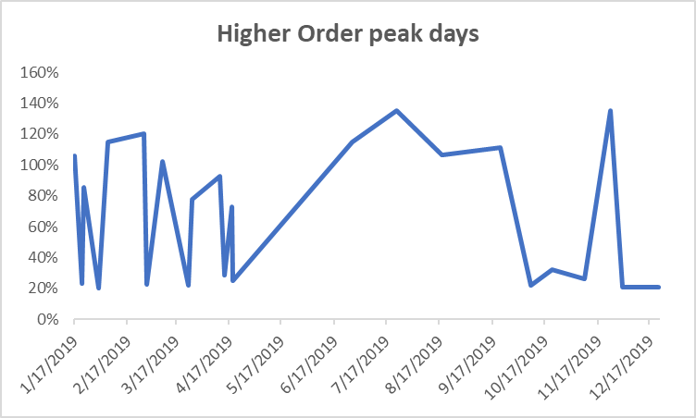

Similarly, the negative peak days aren’t observed in the months of May, October and December.

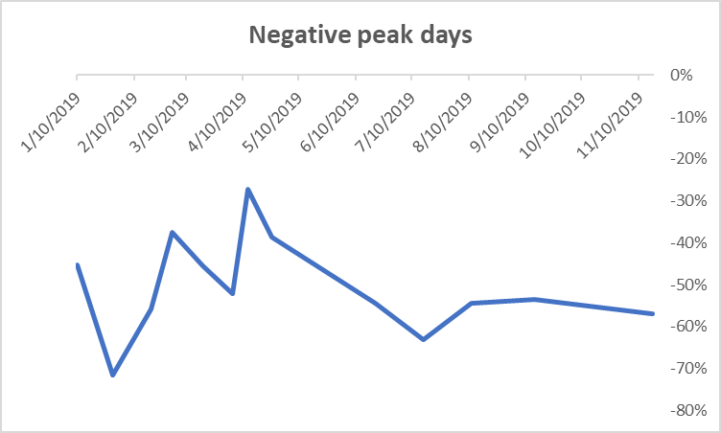

TRENDS ON CONVERSION RATE

The average conversion rate across the Swiggy platform is 5.28% with there are some ups and downs in the conversion rate in the months of January to December.

The possible reasons for the same can be seen on the basis of following trends.



In January, the traffic was affected on two days on 10th January and 22nd January.



On 10th january, the traffic from facebook was reduced to 4% from the 36%. Similarly on 22nd january the traffic from youtube reduced to 5% and the traffic from twitter suddenly increased to 53%.

It was observed that the overall conversion rate improved on 10th january but the conversion rate on 22nd january dropped from 3.3% to 0% from last week. The posssible reason could be the **number of restuarents operating that day were less than the average.**

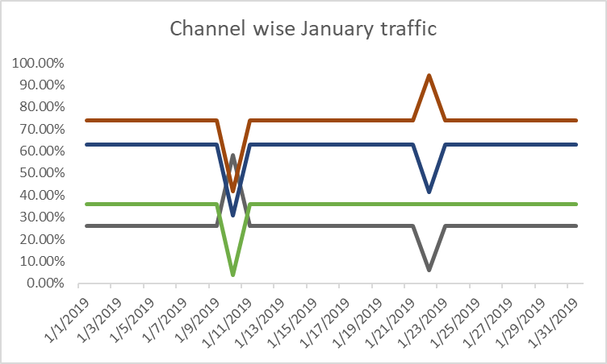



Thus, the following can be concluded.

The change in traffic sources contributed to a positive conversion rate which dropped to -2% compared to 10th January and same can be said for 22nd January also.

**Analysis for the month of FEBRUARY TO DECEMBER**

1. The drop-in conversion rate is responsible because of the traffic change in the previous week from 12th February to 19th February.
2. On 19th March there was a negative conversion rate because of the lower success of payment compared to the 93% of the average success of payment.

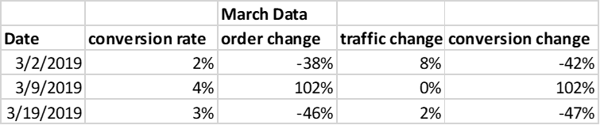

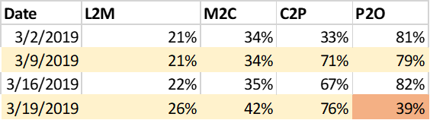

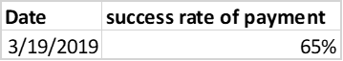

1. In April, there are days of 4th April, 12th April, 18th April and 25th April when compared to previous week’s data, there was a slight drop in L2M conversion from 12th April to 14th April.

Further there was a lower discount of 10% on 4th April which was increased next week to 18% and further to 29% on 18th April which affected the overall conversion rate.

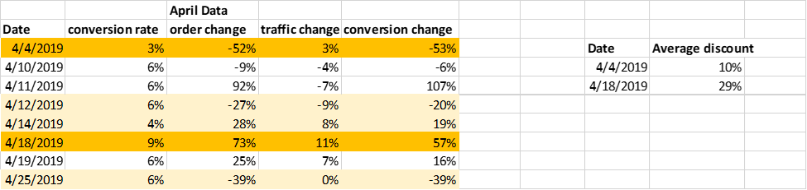

1. There were no unusual trends in the month of **May.**
2. In **June**, the conversion rate is affected by the delivery charges and the cost of preparing for two.

The trends of the following two dates of 13th June and 27th June, the overall cost the customer paying is 5% more on 13th June and 6% less on 27th June.



1. In July, there is a drop-in conversion rate to 2% because of the drop in L2M conversion to 10%. The possible reason could be the increase in out of stock items at the time of listings to menu phase.







1. In August , there is a drop in the conversion rate to 2% on 11th august and the overall

Conversion change drops to -54% from last week.

It can be attributed to the drop in M2C conversion as shown in the table below.

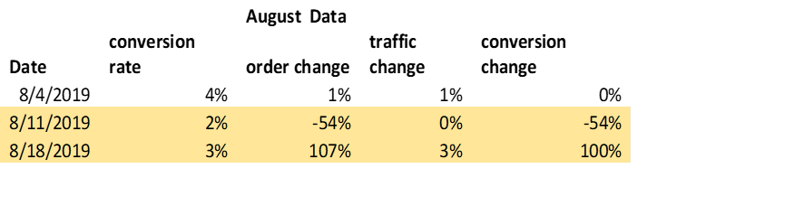

Further, the following drop is due to the increase in the cost of the food for two plus the increase in delivery and packing charges which is called extra charges in the column below.

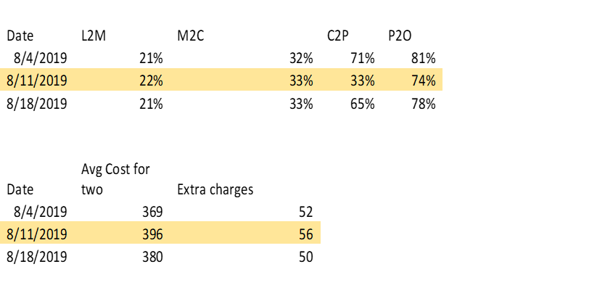

1. Similar trend could be seen in September too. In September the higher delivery charges and packing charges could be a possible reason for the drop in conversion from M2C.





1. in September, we saw increase conversion to 32% compared to previous week on 21st October. There was a **positive traffic change** on 21st october compared to last week as shown in table 1 below.

Also, The out-of-stock items in the month of October were lowest on 21st October, that is 3 compared to other days in the year.





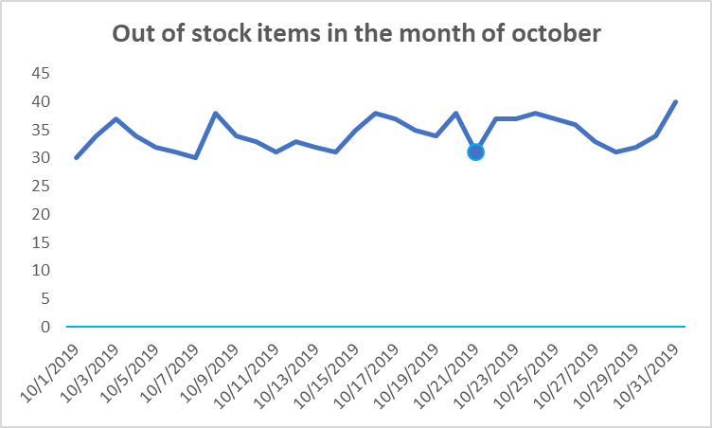

1. The trends of November shows that on 17th November there was negative traffic change and the conversion change was dropped to -54%.

The conversion of M2C was dropped to 14% compared to previous days.





This is because on 17th November, the number of items out of stock were 112 which was way too higher than the average of 35. Hence most of the orders couldn’t reach to cart.

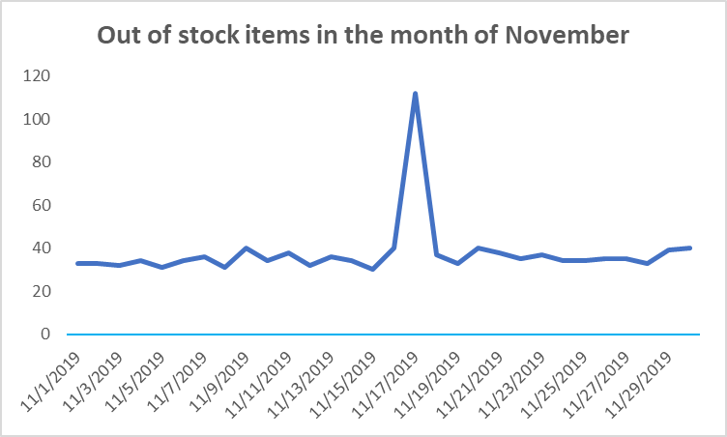

In December, the trend was normalized. There were no unusual highs and lows observed.

**Conclusion and recommendations**

The overall business of the Swiggy is sometimes affected by the various factors as mentioned above.

1. The overall traffic was affected in the month of January. There must be some reasons for the change in traffic source from Facebook and twitter on a particular day. It should be investigated so that this situation can be minimized in the future. If the particular website or traffic source was not providing the service that day then it should be taken into account to have that problem resolved as traffic is the main source for the conversions to happen.
2. The payment system wasn’t working in the month of march which affected the overall conversion from P2O. Alternate payment systems should be tested and launched (if found cost effective) to minimize the negative conversions in future.
3. In some months the restaurants were out of items which impacted the overall orders. An inventory of items needed can be created for the restaurants and restaurants should be sourced on the basis of the orders they get. The data from the previous 3-6 months could be used to create the possible items needed per day, it should also be noted that since the food items are perishable, suitable arrangements must be done by the restaurants. So, that market and brand image of swiggy is not also compromised.
4. The delivery rates are also a factor in drop sometimes. This could be attributed to the lower delivery partners with swiggy.

The following recommendations can be taken into account to improve the overall business of swiggy and less unpredictability.